

**MATHEMATICS**

**3C/3D**

**Semester Two Examination 2012**

**Question/Answer Booklet**

**Section Two:**

**Calculator-Assumed**

Student Name: ________________________________________

Teacher Name ________________________________________

**Time allowed for this section**

Reading time before commencing work: Ten (10) minutes

Working time for this section: One Hundred (100) minutes

**Material required/recommended for this section**

***To be provided by the supervisor***

This Question/Answer Booklet

Formula Sheet

***To be provided by the candidate***

*Standard items: pens, pencils, pencil sharpener, eraser, correction fluid, ruler, highlighters*

Special items: Classpad, Scientific Calculator and 2 pages of back−to−back notes

**Important note to candidates**

No other items may be used in this section of the examination. It is **your** responsibility to ensure that you do not have any unauthorised notes or other items of a non-personal nature in the examination room. If you have any unauthorised material with you, hand it to the supervisor **before** reading any further.

**Structure of this paper**

|  |  |  |  |  |  |
| --- | --- | --- | --- | --- | --- |
| Section | Number of questions available | Number of questions to be answered | Working time (minutes) | Marks available | Percentage of exam |
| Section One:  Calculator-free | 8 | 8 | 50 | 50 | 33 1/3 |
| Section Two:  Calculator-assumed | 13 | 13 | 100 | 100 | 66 2/3 |
|  |  |  |  | 150 | 100 |

**Instructions to candidates**

1. The rules for the conduct of Western Australian external examinations are detailed in the *Year 12 Information Handbook 2012*. Sitting this examination implies that you agree to abide by these rules.

2. Write your answers in the spaces provided in this Question/Answer Booklet. Spare pages are included at the end of this booklet. They can be used for planning your responses and/or as additional space if required to continue an answer.

* + Planning: If you use the spare pages for planning, indicate this clearly at the top of the page.
  + Continuing an answer: If you need to use the space to continue an answer, indicate in the original answer space where the answer is continued, i.e. give the page number. Fill in the number of the question(s) that you are continuing to answer at the top of the page.

3. **Show all your working clearly.** Your working should be in sufficient detail to allow your answers to be checked readily and for marks to be awarded for reasoning. Incorrect answers given without supporting reasoning cannot be allocated any marks. For any question or part question worth more than two marks, valid working or justification is required to receive full marks. If you repeat an answer to any question, ensure that you cancel the answer you do not wish to have marked.

4. It is recommended that you **do not use pencil** except in diagrams.

**Section Two: Calculator-assumed** has **thirteen (13) questions** worth 100 marks. Answer **all** questions. Write your answers in the space provided. Spare pages are included at the end of this booklet. They can be used for planning your responses and/or as additional space if required to continue an answer.

**Question 1 (3, 4, 1, 2, 1 = 11 marks)**

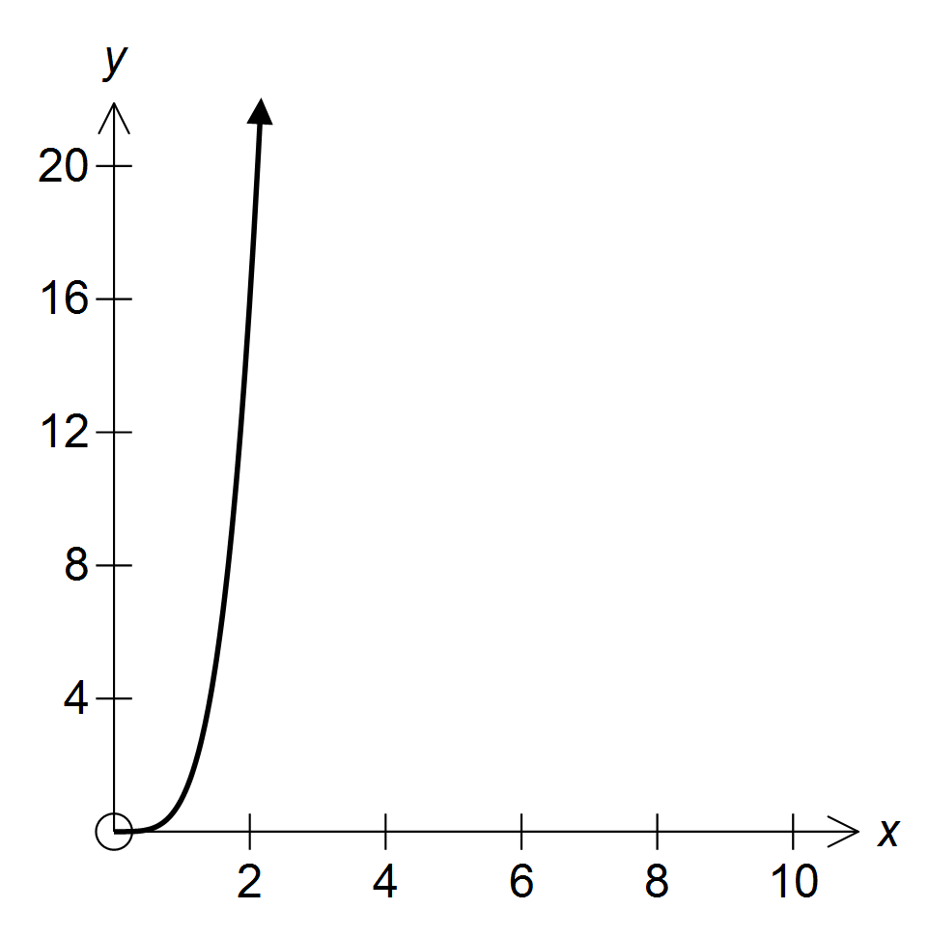

A water tank is obtained by revolving

the curve  about the y−axis.

1. Express the exact volume of water in the tank as a function of its depth *h*
2. Water drains through a small hole in its base at a rate according to:



Show that the water level falls at a constant rate.

1. On the diagram above, draw in a second function 
2. Write an expression for the area enclosed between the two functions and the ***y*−axis**
3. Calculate this area.

**Question 2 (3, 3, 2, 3 = 11 marks)**

Unknown to its customers, a motor vehicle insurance company classifies its drivers as

CLASS A − good risks

CLASS B − medium risks

CLASS C − poor risks based on factors such as age, previous history …

It believes that 30% of the drivers who apply for insurance are CLASS A risks, 50% are CLASS B risks and 20% are CLASS C risks.

The probability that a CLASS A driver will have 1 or more accidents in any 12 month period is 0.01. For a CLASS B driver the probability is 0.05 and for a CLASS C driver the probability is 0.08. Using a tree diagram or otherwise:

1. Determine the probability that a driver will have at least one accident within 12 months of buying an insurance policy from the company
2. If the company sells someone an insurance policy and within 12 months that person has an accident, what is the probability that the driver is a CLASS C risk?

1. On a certain day, 6 different people phone in and apply for insurance from the company. Determine the probability that of those 6
2. less than three of them are good risks
3. the 5th phone call turned out to be the 3rd medium risk driver to apply

**Question 3 (3, 6 = 9 marks)**

1. Prove, showing all working, that for any real number *x* (*x* ≠ 0) the sum of the reciprocals of (1 + *x*) and  is always constant

A

In the diagram O is the centre of the circle, AOBC and CDE are straight lines, ∠ AOE = α and ∠ DCB = θ In addition, ∠ DCB = 2 × ∠ BOD

Prove that 

E α

O

D

B

θ

C

**Question 4 (2, 3, 3, 3 = 11 marks)**

A health food shop packages and sells two different blends of nuts and sultanas.

A packet of Hi−Protein contains 150g of nuts and 50g of sultanas.

A packet of Hi−Energy contains 50g of nuts and 100g of sultanas.

The manager estimates that the shop would need to sell a total of at least 40 packets each day to be profitable but the shop would be unlikely to sell more than 60 packets in total.

Because of commitments to suppliers, the shop must package at least ‘*p*’ kg of nuts and at least 3 kg of sultanas each day. Let *x* represent the number of packets of Hi−Protein and *y* the number of packets of Hi−Energy sold each day.

*y*

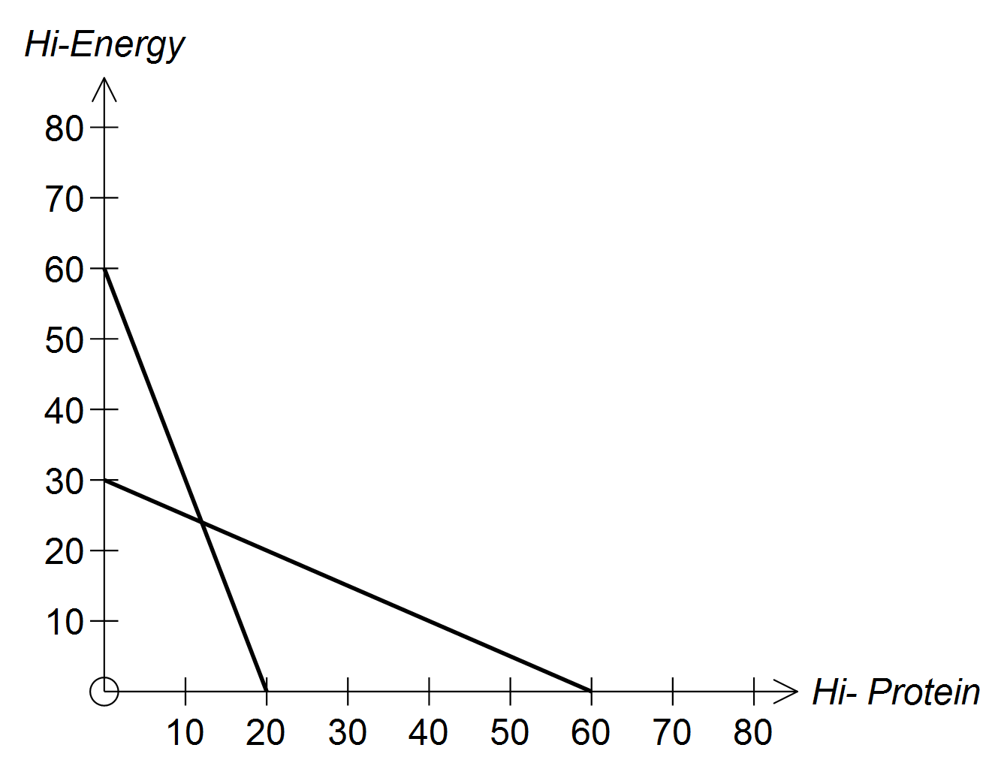

*x*

1. In the above graph two of the lines determining the boundaries of the feasible region have been drawn. Determine the value of ‘*p*’
2. Write down and then draw in the other two boundary lines and indicate clearly the feasible region.

The profit on each packet of Hi−Protein is $1.20 and on each packet of Hi−Energy $1.60.

1. Using the feasible region from (b), determine the **least** possible profit and the number of packets of each blend that would need to be sold to achieve this profit.
2. If the profit on each packet of Hi−Energy remains at $1.60, to what value must the profit on each packet of Hi−Protein fall in order that your solution to (c) is not unique

**Question 5 (5, 2 = 7 marks)**

After clearing all the trees from a river valley, it has been found that the rate of increase in the concentration of salt in the topsoil at a given distance from the riverbank, *d* metres, is given by  for 0 < *d* < 100

where *b* = a real constant

*S* = salt concentration in parts per million

*t* = time in years after clearing

Immediately after the clearing of the valley, the following measurements were taken: at *d* = 1 m *S*  was 100 parts per million of salt and at *d* = 9 m, *S* was 90 parts per million of salt.

1. Determine the expression for the concentration of *S* in terms of *t* and *d* using the initial measurements given.

1. Find the concentration of salt expected 50 years after clearing and at a position of 30 m from the riverbank.

**Question 6 (1, 1, 2, 2 = 6 marks)**

A television director for the closing ceremony of the Olympic Games has two different commercials for each of 6 products. These are to be shown during three commercial breaks. Each break has four commercials and each commercial is shown only once. It is possible for both commercials for the same product to be shown during the same break.

The director places the commercials into groups of four, choosing the commercials for the first break, then choosing the four commercials for the second break and finally the four for the last break.

1. How many groups could the director choose for the
2. 1st break
3. 2nd break

Now consider the first group of four commercials.

1. In how many different orders can the commercials be shown if :
2. they are all different products
3. there are only two products advertised and the two advertisements for each product are not shown consecutively

**Question 7 (2, 3, 1 = 6 marks)**

Two houses A and B are respectively 4 and 6 km from two points P and Q on a straight road as shown in the diagram below.

B

A

P *x* T Q

Eastern Power Company are to erect one power pole (T) between P and Q so that it can serve both houses. Once erected, power lines AT and BT will be put in place. Given PQ = 5 km, and *x* the distance between P and T:

1. show that the distance TA + TB can be represented by:



Eastern Power Company wish to minimise the distance TA + TB.

1. Use calculus to determine how far from P the pole should be erected in order that the distance TA + TB is a minimum.
2. verify that the distance found in (ii) is a minimum.

**Question 8 (1, 1, 2, 3 = 7 marks)**

650 g labelled cartons of free-range farm eggs are filled automatically according to the uniform probability density function:



1. determine the probability that the carton will be filled with eggs weighing less than 647.5 g

If the standard deviation of a uniform distribution  is given by 

1. Calculate the standard deviation for this distribution

Several samples of 40 cartons each were examined by Government authorities and the mean weight of each sample calculated.

1. Describe the probability distribution that best models this distribution of sample means
2. Find the probability that a randomly chosen sample has a mean no less than 650 g given it is no more than 651 g

**Question 9 (1, 3, 3 = 7 marks)**

The amount A of a drug in the bloodstream will decline at a rate proportional to the current amount. That is  where E hours is a constant called the elimination time.

1. write down the formula for *A(t)* the amount of the drug in the bloodstream after *t* hours, in terms of *t*, *E* and the initial amount 
2. what percentage of the drug (correct to two decimal places), remains after E hours?

The drug sodium pentobarbitol can be used to tranquillize animals. A dog is tranquillized if its bloodstream contains at least 45 milligrams of the drug for each kilogram of the dog’s weight. The elimination time for the drug is 6 hours.

1. what single dose of this drug should be given in order to tranquillize a 12 kg dog for 1 hour? .

**Question 10 (1, 1, 2, 5 = 9 marks)**

1. In a game involving two players, the players take turns to toss three fair coins. They keep tossing the coins until they all appear as heads. The player who makes such a toss is the winner.
2. Calculate  the probability that the game is won on the first

toss

1. Calculate  the probability that the game is won on the second

toss

1. Write a formula for  the probability that the game is won on the nth toss
2. For two independent events *A* and *B*, 

Determine *P(A)* and *P(B)*

**Question 11 (3, 2 = 5 marks)**

A

D

X

.

O

C

B

AB and CD are two chords of a circle centre O, that intersect at point X

1. Prove that Δ ADX ~ Δ CBX
2. Hence or otherwise, find AX if BX = 12 CX = 9 and DX = 4

**Question 12 (2, 3 = 5 marks)**

The safe lifetime of standard radial tyres under regular driving conditions are normally distributed with a mean 20 000 km and a standard deviation of 1500 km

1. What is the probability that a standard radial tyre will last longer than

21 000 km if it has already lasted 18 000 km

The tyre company also produce the Extra Grip radial tyre, whose lifetimes are also normally distributed with the same standard deviation of 1500 km but with a possibly different mean  hours. A quality control expert at the company wishes to estimate  using the mean lifetime of a random sample of Extra Grip radial tyres.

1. How large should the sample be in order to be at least 95% confident that the estimate will be no more than 200 km in error?

**Question 13 (2, 4 = 6 marks)**

A train starts from rest and moves with a constant acceleration until it reaches a speed of 15 m/sec. It continues at this speed for a period of time, after which it is brought to rest with a constant retardation or de-acceleration. The total time taken is 22 seconds and the distance travelled is 240 m. If the time taken for the retardation is half that for the acceleration:

1. Sketch a velocity − time graph
2. Determine the amount of time the train takes to accelerate to its maximum speed.

**END OF SECTION 2**

SPARE PAGES FOR WORKING

SPARE PAGES FOR WORKING

SPARE PAGES FOR WORKING

SPARE PAGES FOR WORKING